Intro to SQL Commands - DDL

✅ What is SQL Commands – DDL (Data Definition Language)?
# Source: AI Source: Provided by: [Data Path: Persons Table -> ID Column: 1, Name_En Column: Motasem Essam] -> From: [ChatGPT] on [6/11/2026]
SQL Commands - DDL stands for Data Definition Language. These are SQL commands used to define, create, modify, and delete database structures like tables, schemas, indexes, and views — essentially, they define the structure of a database.

Common DDL Commands
# Source: AI Source: Provided by: [Data Path: Persons Table -> ID Column: 1, Name_En Column: Motasem Essam] -> From: [ChatGPT] on [6/11/2026]
Here are the main DDL commands:
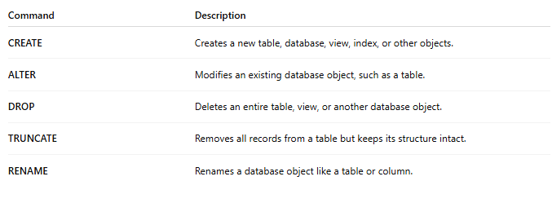
Command | Description
CREATE | Creates a new table, database, view, index, or other objects.
ALTER | Modifies an existing database object, such as a table.
DROP | Deletes an entire table, view, or another database object.
TRUNCATE | Removes all records from a table but keeps its structure intact.
RENAME | Renames a database object like a table or column.

Examples

1. CREATE
# Source: AI Source: Provided by: [Data Path: Persons Table -> ID Column: 1, Name_En Column: Motasem Essam] -> From: [ChatGPT] on [6/11/2026]
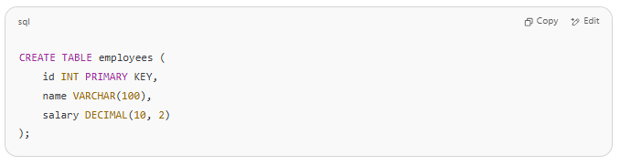
CREATE TABLE employees (
id INT PRIMARY KEY,
name VARCHAR(100),
salary DECIMAL(10, 2)
);

2. ALTER
# Source: AI Source: Provided by: [Data Path: Persons Table -> ID Column: 1, Name_En Column: Motasem Essam] -> From: [ChatGPT] on [6/11/2026]
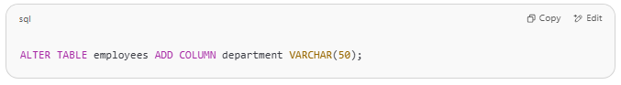
ALTER TABLE employees ADD COLUMN department VARCHAR(50);

3. DROP
# Source: AI Source: Provided by: [Data Path: Persons Table -> ID Column: 1, Name_En Column: Motasem Essam] -> From: [ChatGPT] on [6/11/2026]
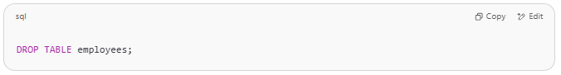
DROP TABLE employees;

4. TRUNCATE
# Source: AI Source: Provided by: [Data Path: Persons Table -> ID Column: 1, Name_En Column: Motasem Essam] -> From: [ChatGPT] on [6/11/2026]
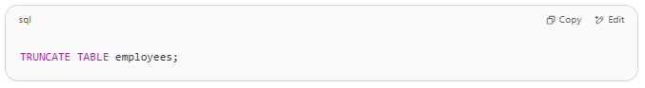
TRUNCATE TABLE employees;

5. RENAME
# Source: AI Source: Provided by: [Data Path: Persons Table -> ID Column: 1, Name_En Column: Motasem Essam] -> From: [ChatGPT] on [6/11/2026]
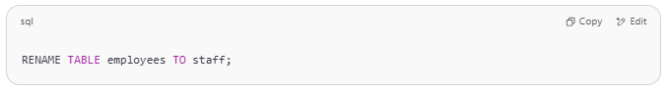
RENAME TABLE employees TO staff;

Key Notes
# Source: AI Source: Provided by: [Data Path: Persons Table -> ID Column: 1, Name_En Column: Motasem Essam] -> From: [ChatGPT] on [6/11/2026]
- DDL commands change the schema of the database.
- They are auto-committed, which means the changes are permanent and cannot be rolled back (in most databases).
- These commands are crucial during the design and maintenance phases of a database.

